 |  | E  TG/179/3

INTERNATIONAL UNION FOR THE PROTECTION  OF NEW VARIETIES OF PLANTS | UNION INTERNATIONALE POUR LA PROTECTION  DES OBTENTIONS VÉGÉTALES | INTERNATIONALER VERBAND ZUM SCHUTZ VON PFLANZEN-ZÜCHTUNGEN | UNIÓN INTERNACIONAL PARA LA PROTECCIÓN  DE LAS OBTENCIONES VEGETALES

GUIDELINES

FOR THE CONDUCT OF TESTS

FOR DISTINCTNESS, UNIFORMITY AND STABILITY

WHITE MUSTARD

(Sinapis alba L. )

GENEVA
2001

Copies of this document are available on request at the price of 10 Swiss francs each, including surface mail, from the Office of UPOV, 34, chemin des Colombettes, P.O. Box 18, 1211 Geneva 20, Switzerland

This document or parts of it may be reproduced, translated and published without obtaining the specific consent of UPOV, provided that the source is acknowledged.

* * * * * * *
TG/179/3
ORIGINAL: English
DATE: 2001-04-04

INTERNATIONAL UNION FOR THE PROTECTION  OF NEW VARIETIES OF PLANTS | UNION INTERNATIONALE POUR LA PROTECTION  DES OBTENTIONS VÉGÉTALES | INTERNATIONALER VERBAND ZUM SCHUTZ VON PFLANZEN-ZÜCHTUNGEN | UNIÓN INTERNACIONAL PARA LA PROTECCIÓN  DE LAS OBTENCIONES VEGETALES

GUIDELINES

FOR THE CONDUCT OF TESTS

FOR DISTINCTNESS, UNIFORMITY AND STABILITY

WHITE MUSTARD

(Sinapis alba L. )

These Guidelines should be read in conjunction with document TG/1/2, which contains explanatory notes on the general principles on which the Guidelines have been established.

TABLE OF CONTENTS PAGE

- Subject of these Guidelines……………………………………………………… 3
- Material Required……………………………………………………………….. 3
- Conduct of Tests………………………………………………………………… 3
- Methods and Observations……………………………………………………… 3
- Grouping of Varieties…………………………………………………………… 4
- Characteristics and Symbols……………………………………………………... 4
- Table of Characteristics…………………………………………………………... 6
- Explanations on the Table of Characteristics……………………………………. 11
- Literature………………………………………………………………………… 17
- Technical Questionnaire………………………………………………………… 18
I. Subject of these Guidelines

These Test Guidelines apply to all varieties of Sinapis alba L.

II. Material Required

1. The competent authorities decide when, where and in what quantity and quality the plant material required for testing the variety is to be delivered. Applicants submitting material from a State other than that in which the testing takes place must make sure that all customs formalities are complied with. The minimum quantity of seed to be supplied by the applicant in one or several samples should be:

500 g

The seed should at least meet the minimum requirements for germination capacity, moisture content and purity for marketing certified seed in the country in which the application is made. The germination capacity should be as high as possible.

2. The plant material must not have undergone any treatment unless the competent authorities allow or request such treatment. If it has been treated, full details of the treatment must be given.

III. Conduct of Tests

1. The minimum duration of tests should normally be two independent growing cycles.

2. The tests should normally be conducted at one place. If any important characteristics of the variety cannot be seen at that place, the variety may be tested at an additional place.

3. The field tests should be carried out under conditions ensuring normal growth. The distance between rows and between plants within the rows should be adjusted to enable observations on individual plants. The size of the plots should be such that plants or parts of plants may be removed for measurement and counting without prejudice to the observations which must be made up to the end of the growing period. Each test should include as a minimum 300 plants which should be divided between three or more replicates. In addition each test should include a replicate of minimum 300 plants for the characteristics assessed by observation of a group of plants.

4. Additional tests for special purposes may be established.

IV. Methods and Observations

- Unless otherwise stated, all observations for assessment of distinctness and stability should be made on 60 plants or parts taken from each of 60 plants.

- For the assessment of uniformity

- unless otherwise stated, all observations determined by measurements should be made on 60 plants or parts taken from each of 60 plants (MS)

- all single observations of a group of plants or parts of plants should be made on the total plot of minimum 300 plants.

The variability within the variety should not exceed the variability of comparable varieties already known.

3. Interpretation of results should be made according to the rules for cross-pollinated varieties as stated in the General Introduction to the Test Guidelines.

V. Grouping of Varieties

1. The collection of varieties to be grown should be divided into groups to facilitate the assessment of distinctness. Characteristics which are suitable for grouping purposes are those which are known from experience not to vary, or to vary only slightly, within a variety. Their various states of expression should be fairly evenly distributed throughout the collection.

2. It is recommended that the competent authorities use the following characteristics for grouping varieties:

- Seed: erucic acid (characteristic 1)
- Ploidy (characteristic 2)

- Flower: yellow color of petals (characteristic 13)

VI. Characteristics and Symbols

1. To assess distinctness, uniformity and stability, the characteristics and their states as given in the Table of Characteristics should be used.

2. Notes (numbers), for the purposes of electronic data processing, are given opposite the states of expression for each characteristic. For each characteristic it is indicated whether measurements of a number of single plants or parts of plants (MS), measurement of a group of plants or parts of plants (MG) or visual assessments by a single observation of a group of plants or parts of plants (VG) should be used.
3. Legend:

(*) Characteristics that should be used on all varieties in every growing period over which examinations are made and always be included in the variety descriptions, except when the state of expression of a preceding characteristic or regional environmental conditions render this impossible.

(+) See Explanations on the Table of Characteristics in Chapter VIII.

- The optimum stage of development for the assessment of each characteristic is indicated by a number in the second column. The stages of development denoted by each number are described at the end of chapter VIII.

MG: measurement of a group of plants or parts of plants
MS: measurement of a number of single plants or parts of plants
VG: visual assessment by a single observation of a group of plants or parts of plants

VII. Table of Characteristics/Tableau des caractères/Merkmalstabelle/Tabla de caracteres

 | Stage ¹⁾  Stade ¹⁾  Stadium ¹⁾  Estado ¹⁾ | English | français | deutsch | español | Example Varieties  Exemples  Beispielssorten  Variedades ejemplo | Note/  Nota
1.  (*)  (+) | 00 | Seed: erucic acid | Semence: acide érucique | Samen: Erucasäure | Semilla: ácido erúcico
 |  | absent | absent | fehlend | ausente | Rizo | 1
 |  | present | présent | vorhanden | presente | Emergo | 9
2.  (*)  (+) | 05 | Ploidy | Ploïdie | Ploidie | Ploidía
 |  | diploid | diploïde | diploid | diploide | Emergo | 2
 |  | tetraploid | tétraploïde | tetraploid | tetraploide | Oscar | 4
3.  (+) | 11  MS | Cotyledon: length | Cotylédon: longueur | Keimblatt: Länge | Cotiledón: longitud
 |  | short to medium | court à moyen | kurz bis mittel | corta a media | Rizo | 4
 |  | medium | moyen | mittel | media | Emergo | 5
 |  | medium to long | moyen à long | mittel bis lang | media a larga | Silenda | 6
4.  (+) | 11  MS | Cotyledon: width | Cotylédon:  largeur | Keimblatt: Breite | Cotiledón: anchura
 |  | narrow | étroit | schmal | estrecha |  | 3
 |  | medium | moyen | mittel | media | Emergo | 5
 |  | broad | large | breit | ancha | Silvester | 7
5.  (*) | 16-59  VG | Leaf: green color | Feuille: couleur verte | Blatt: Grünfärbung | Hoja: color verde
 |  | light | claire | hell | clara |  | 3
 |  | medium | moyenne | mittel | media | Emergo | 5
 |  | dark | foncée | dunkel | oscura | Silvester | 7
6.  (+) | 16-59  MS | Leaf: number of lobes (fully developed leaf) | Feuille: nombre  de lobes (feuille complètement développée) | Blatt: Anzahl Lappen (vollständig entwickeltes Blatt) | Hoja: número de lóbulos (hoja completamente desarrollada)
 |  | few | faible | gering | bajo | Maxi | 3
 |  | medium | moyen | mittel | medio | Emergo | 5
 |  | many | grand | groß | alto | Perine | 7
7.  (+) | 16-59  VG | Leaf: dentation of margin | Feuille:  dentelure du bord | Blatt: Zähnung des Randes | Hoja: dentado del borde
 |  | weak | faible | gering | débil | Gedney | 3
 |  | medium | moyenne | mittel | medio | Oscar | 5
 |  | strong | forte | stark | fuerte |  | 7
8.  (*) (+) | 16-59  MS | Leaf: length (blade and petiole) | Feuille:  longueur (limbe  et pétiole) | Blatt: Länge (Spreite und Stiel) | Hoja: longitud (limbo y pecíolo)
 |  | short | courte | kurz | corta | Rizo | 3
 |  | medium | moyenne | mittel | media | Emergo | 5
 |  | long | longue | lang | larga | Sirola | 7
9.  (*) (+) | 16-59  MS | Leaf: width (widest point) | Feuille: largeur  (au point le plus large) | Blatt: Breite (an breitester Stelle) | Hoja: anchura (en el punto más ancho)
 |  | narrow | étroite | schmal | estrecha | Medico | 3
 |  | medium | moyenne | mittel | media | Emergo | 5
 |  | broad | large | breit | ancha | Oscar | 7
10.  (*) (+) | 16-59  MS | Leaf: length of petiole | Feuille :  longueur du  pétiole | Blatt: Länge des Stieles | Hoja: longitud del pecíolo
 |  | short | courte | kurz | corta | Rizo | 3
 |  | medium | moyenne | mittel | media | Emergo | 5
 |  | long | longue | lang | larga | Sirola | 7
11.  (*) (+) | MS | Time of flowering | Époque de  floraison | Zeitpunkt der Blüte | Época de la floración
 |  | very early | très précoce | sehr früh | muy precoz | Carla | 1
 |  | early | précoce | früh | precoz | Silenda | 3
 |  | medium | moyenne | mittel | medio | Litember | 5
 |  | late | tardive | spät | tardía | Sito | 7
 |  | very late | très tardive | sehr spät | muy tardía |  | 9
12.  (*) (+) | MG | Plant: height at flowering | Plante: hauteur  au moment de la floraison | Pflanze: Höhe zur Zeit der Blüte | Planta: altura en floración
 |  | low | basse | niedrig | baja | Serval | 3
 |  | medium | moyenne | mittel | media | Maxi | 5
 |  | tall | haute | hoch | alta | Litember | 7
13.  (*) | 65  VG | Flower: yellow color of petals | Fleur: couleur jaune des pétales | Blüte: Gelbfärbung der Blütenblätter | Flor: color amarillo de los pétalos
 |  | light | claire | hell | clara | Figaro | 3
 |  | medium | moyenne | mittel | media | Maxi | 5
 |  | dark | foncée | dunkel | oscura |  | 7
14. | 65  MS | Flower: length of petals | Fleur: longueur des pétales | Blüte: Länge des Blütenblattes | Flor: longitud de los pétalos
 |  | short to medium | basse à moyenne | niedrig bis mittel | baja a media | Silenda | 4
 |  | medium | moyenne | mittel | media | Caralba | 5
 |  | medium to long | moyenne à longue | mittel bis lang | media a larga | Samba | 6
15. | 65  MS | Flower: width of petals | Fleur: largeur des pétales | Blüte: Breite des Blütenblattes | Flor: anchura de los pétalos
 |  | narrow to medium | étroits à moyens | schmal bis mittel | estrecha a media | Martigena | 4
 |  | medium | moyens | mittel | media | Ultra | 5
 |  | medium to broad | moyens à larges | mittel bis breit | media a ancha | Oscar | 6
16. (*) | 89  MS | Plant: total length | Plante: longueur totale | Pflanze: Gesamtlänge | Planta: longitud total
 |  | short | courte | kurz | corta | Silenda | 3
 |  | medium | moyenne | mittel | media | Perine | 5
 |  | long | longue | lang | larga | Litember | 7
17. (*)  (+) | 89  MS | Siliqua: length (between peduncle and beak) | Silique:  longueur (entre  le pédoncule et le bec) | Schote: Länge (zwischen Stiel und Spitze) | Silicua: longitud (entre el pedúnculo y el rostro)
 |  | short | courte | kurz | corta | Emergo | 3
 |  | medium | moyenne | mittel | media | Litember | 5
 |  | long | longue | lang | larga | Fighter | 7
18.  (*)  (+) | 89  MS | Siliqua: length of beak | Silique:  longueur du bec | Schote: Länge der Spitze | Silicua: Longitud del rostro
 |  | short | courte | kurz | corta | Carnaval | 3
 |  | medium | moyenne | mittel | media | Torpedo | 5
 |  | long | longue | lang | larga | Silvester | 7
19.  (+) | 89  MS | Siliqua: width | Silique: largeur | Schote: Breite | Silicua: anchura
 |  | narrow | étroite | schmal | estrecha |  | 3
 |  | medium | moyenne | mittel | media | Maxi | 5
 |  | broad | large | breit | ancha | Silvester | 7
20.  (+) | 89  MS | Siliqua: length of peduncle | Silique:  longueur du pédoncule | Schote: Länge des Stieles | Silicua: longitud del pedúnculo
 |  | short | courte | kurz | corta | Sirola | 3
 |  | medium | moyenne | mittel | media | Litember | 5
 |  | long | longue | lang | larga | Silvester | 7
21. | 89  MS | Siliqua: number of seeds | Silique: nombre  de grains | Schote: Anzahl Samen | Silicua: número de semillas
 |  | low | petit | gering | bajo | Silvester | 3
 |  | medium | moyen | mittel | medio | Maxi | 5
 |  | high | grand | groß | alto | Litember | 7
22.  (+) | 89  MS | Seed: thousand seed weight | Semence: poids  de mille grains | Samen: Tausendkorngewicht | Semilla: peso de mil semillas
 |  | low | petit | niedrig | pequeño | Rizo | 3
 |  | medium | moyen | mittel | medio | Silenda | 5
 |  | high | grand | hoch | grande | Oscar | 7
23.  (+) | VG | Generative development in year of sowing for late summer sown trials | Formation d’inflorescences, l’année du semis dans un essai semé tard en été | Generative Entwicklung im Aussaatjahr bei Spätsommer  aussaat | Desarrollo generativo el año de siembra en los ensayos sembrados al final del verano
 |  | absent or very weak | absent ou très faible | fehlend oder sehr gering | ausente o muy débil |  | 1
 |  | weak | faible | gering | débil | Sina | 3
 |  | medium | moyen | mittel | media | Silvester | 5
 |  | strong | grand | stark | fuerte | Maxi | 7
 |  | very strong | très grand | sehr stark | muy fuerte | Rizo | 9

VIII. Explanations on the Table of Characteristics

Ad. 1: Seed: erucic acid

The erucic acid content should be observed on seed sent in by the applicant. It should be expressed as a percentage by mass of methyl esters in accordance with the ISO standard in document 5508, paragraph 6.2.2.1. Seed containing 2% or less of erucic acid will be classified as “absent.”

Ad. 2: Ploidy

Ploidy should be assessed on at least 100 seedlings.

Ad. 3 + 4: Cotyledon: length (3) and width (4)
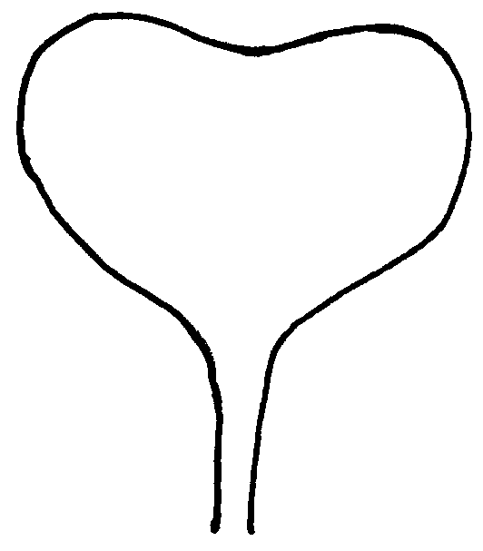
4 mm
3
4
The measurement should be taken in the glasshouse. If the two cotyledons differ in size, the bigger one should be measured. The length is defined as distance between the inclination at top of the cotyledon and the point where the width of the petiole is about 4 mm. The width of the cotyledon should be measured at the widest point of the cotyledons.

Ad. 6: Leaf: number of lobes

Parts of the leaf blade are considered as lobes if their length is at least equivalent to the width of the leaf petiole at their point of attachment and if the upper notch of the blade has at least half the length of the lobe itself.

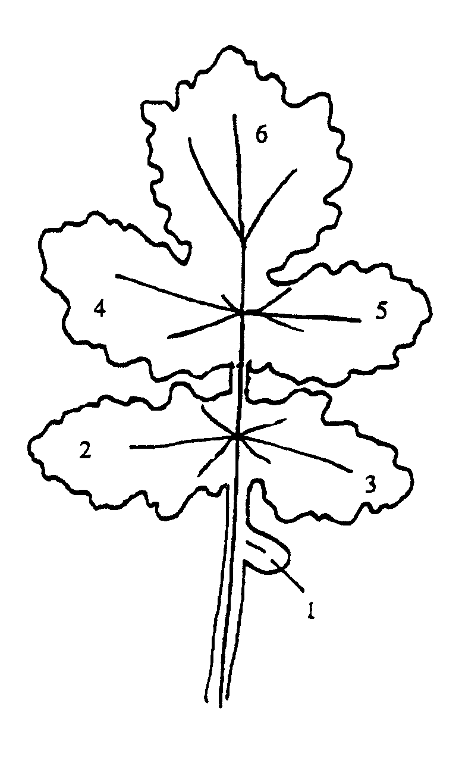

Ad. 7-10: Leaf: dentation (7), length (8), width (9), length of petiole (10)
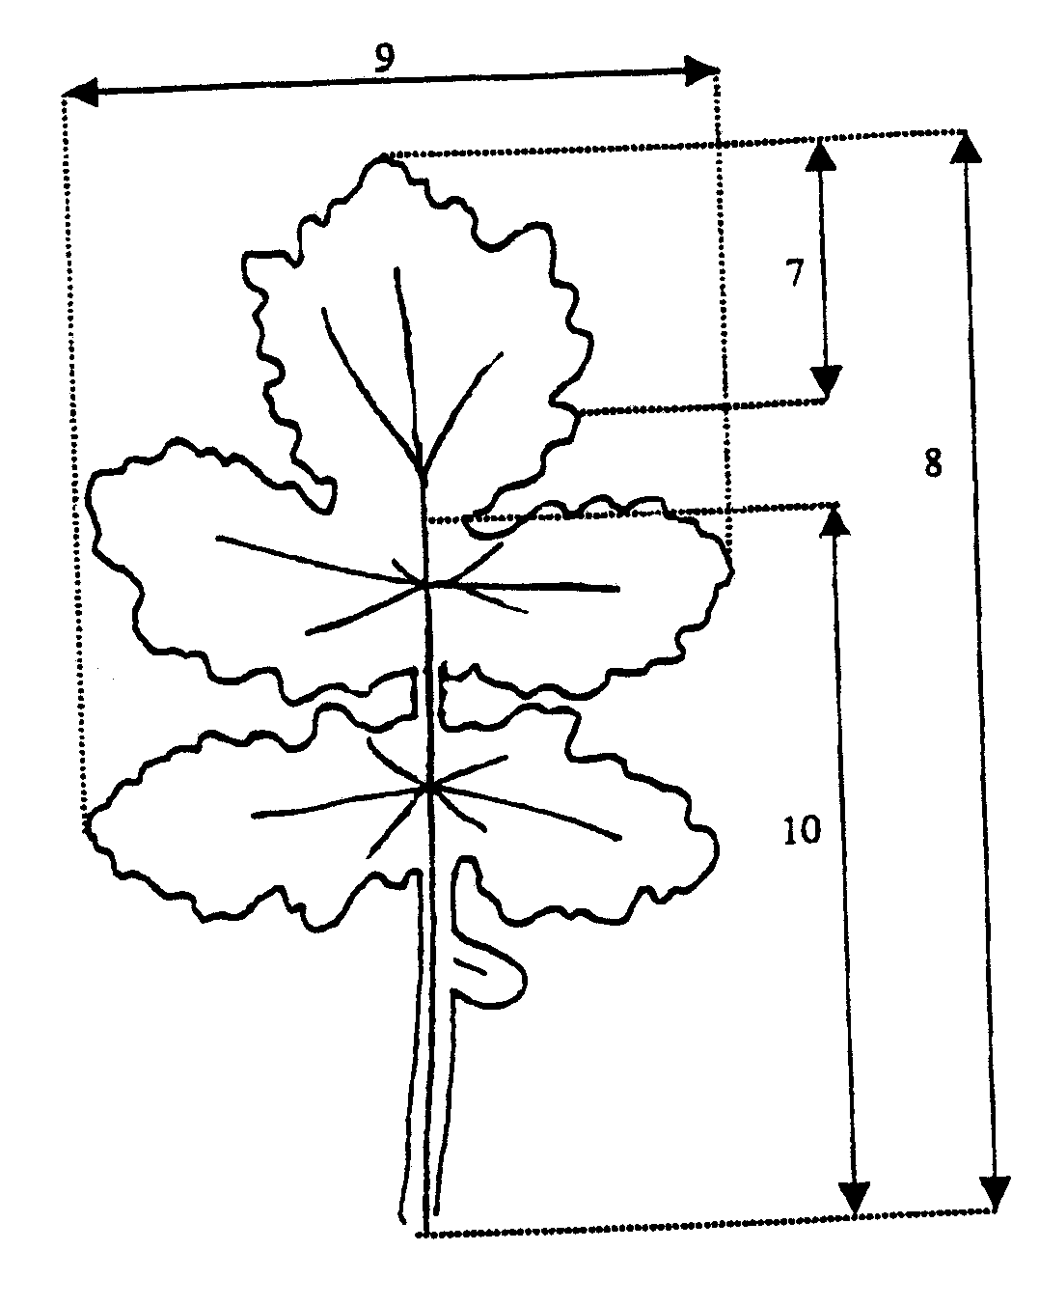
7 = part on which the dentation should be recorded (characteristic 7)

Ad. 11: Time of flowering

The observation should be done at least three times per week and more frequently if there is any need to do so. The date should be calculated - if necessary by interpolation - at which 50% of plants show at least one open flower.

When assessed on the plot as a whole, the recommended percentage is 10%.
This characteristic may be useful for arranging the varieties in the collection.

Ad. 12 : Plant: height at flowering

The height of the plants should be assessed when all normally developed plants have opened at least one flower.

Ad. 17-21: Siliqua

All observations on the siliqua should be recorded in the midpart of the inflorescence of the main stem.

Ad. 22: Seed: thousand seed weight

Per replicate a bulk sample of 20 siliques should be taken.

Ad. 23: Generative development in year of sowing for late summer sown trials

The observation of the growth stages reached (proportion of plants below bud stage, in bud stage, in flowering stage, in stage of siliqua formation) should be made in autumn, when the development stagnates.

Alternatively the beginning of flowering may be observed in this trial; early flowering would mean strong generative development, late flowering would mean weak development.
Phenological growth stages according to the BBCH-identification keys of oilseed rape
(Meier, 1997)

Code | Description
Principal growth stage 0: Germination
00 | Dry seed
01 | Beginning of seed imbibition
03 | Seed imbibition complete
05 | Radicle emerged from seed
07 | Hypocotyl with cotyledons emerged from seed
08 | Hypocotyl with cotyledons growing towards soil surface
09 | Emergence: cotyledons emergence through soil surface
Principal growth stage 1: Leaf development
10 | Cotyledons completely unfolded
11 | First leaf unfolded
12 | 2 leaves unfolded
13 | 3 leaves unfolded
14 | 4 leaves unfolded
15 | 5 leaves unfolded
16 | 6 leaves unfolded
17 | 7 leaves unfolded
18 | 8 leaves unfolded
19 | 9 or more leaves unfolded
Principal growth stage 2: Formation of side shoots
20 | No side shoots
21 | Beginning of side shoot development: first side shoot visible
22 | 2 side shoots visible
23 | 3 side shoots visible
24 | 4 side shoots visible
25 | 5 side shoots visible
26 | 6 side shoots visible
27 | 7 side shoots visible
28 | 8 side shoots visible
29 | End of side shoot development: 9 or more side shoots visible
Principal growth stage 3: Stem elongation
30 | Beginning of stem elongation: no internodes (‘rosette’)
31 | 1 visibly extended internodes
32 | 2 visibly extended internodes
33 | 3 visibly extended internodes
34 | 4 visibly extended internodes
35 | 5 visibly extended internodes
36 | 6 visibly extended internodes
37 | 7 visibly extended internodes
38 | 8 visibly extended internodes
39 | 9 or more visibly extended internodes
Principal growth stage 4: --

Code | Description
Principal growth stage 5: Inflorescence emergence
50 | Flower buds present, still enclosed by leaves
51 | Flower buds visible from above (“green bud”)
52 | Flower buds free, level with the youngest leaves
53 | Flower buds raised above the youngest leaves
55 | Individual flower buds (main inflorescence) visible but still closed
57 | Individual flower buds (secondary inflorescences) visible but still closed
59 | First petals visible, flower buds still closed (“yellow bud”)
Principal growth stage 6: Flowering
60 | First flowers open
61 | 10 % of flowers on main raceme open, main raceme elongating
62 | 20 % of flowers on main raceme open
63 | 30 % of flowers on main raceme open
64 | 40 % of flowers on main raceme open
65 | Full flowering: 50 % flowers on main raceme open, older petals falling
67 | Flowering declining: majority of petals fallen
69 | End of flowering
Principal growth stage 7: Development of fruit
71 | 10 % of pods have reached final size
72 | 20 % of pods have reached final size
73 | 30 % of pods have reached final size
74 | 40 % of pods have reached final size
75 | 50 % of pods have reached final size
76 | 60 % of pods have reached final size
77 | 70 % of pods have reached final size
78 | 80 % of pods have reached final size
79 | Nearly all pods have reached final size
Principal growth stage 8: Ripening
80 | Beginning of ripening: seed green, filling pod cavity
81 | 10 % of pods ripe, seeds dark and hard
82 | 20 % of pods ripe, seeds dark and hard
83 | 30 % of pods ripe, seeds dark and hard
84 | 40 % of pods ripe, seeds dark and hard
85 | 50 % of pods ripe, seeds dark and hard
86 | 60 % of pods ripe, seeds dark and hard
87 | 70 % of pods ripe, seeds dark and hard
88 | 80 % of pods ripe, seeds dark and hard
89 | Fully ripe: nearly all pods ripe, seeds dark and hard

IX. Literature

Growth stages of mono- and dicotyledonous plants: BBCH-Monograph. Federal Biological Research Centre of Agriculture and Forestry (ed.) Ed. by Uwe Meier.-Berlin; Wien [u.a.]: Blackwell Wiss.-Verl., 1997.

X. Technical Questionnaire

Reference Number
(not to be filled in by the applicant)

TECHNICAL QUESTIONNAIRE
to be completed in connection with an application for plant breeders’ rights

1. Species Sinapis alba L.

WHITE MUSTARD

2. Applicant (Name and address)

3. Proposed denomination or breeder’s reference

4. Information on origin, maintenance and reproduction of the variety

4.1 Genetic origin and breeding method

4.2 Other information

5. Characteristics of the variety to be indicated (the number in brackets refers to the corresponding characteristic in Test Guidelines; please mark the state of expression which best corresponds).
 | Characteristics | Example Varieties | Note
5.1  (1) | Seed: erucic acid
 | absent | Rizo | 1 [ ]
 | present | Emergo | 9 [ ]
5.2  (2) | Ploidy
 | diploid | Emergo | 2 [ ]
 | tetraploid | Oscar | 4 [ ]
5.3  (11) | Time of flowering
 | very early | Carla | 1 [ ]
 | early | Silenda | 3 [ ]
 | medium | Litember | 5 [ ]
 | late | Sito | 7 [ ]
 | very late |  | 9 [ ]

 | Characteristics |  |  | Example Varieties |  | Note
5.4  (16) | Plant: total length
 | short |  |  | Silenda |  | 3 [ ]
 | medium |  |  | Perine |  | 5 [ ]
 | long |  |  | Litember |  | 7 [ ]
6. Similar varieties and differences from these varieties

Denomination of similar variety |  | Characteristic in which the similar variety is different ^{o)} | State of expression of similar variety |  | State of expression of candidate variety
______________
^{o)} In the case of identical states of expressions of both varieties, please indicate the size of the difference.

7. Additional information which may help to distinguish the variety

7.1 Resistance to pest and diseases

7.2 Special conditions for the examination of the variety

7.3 Other information

8. Authorization for release

(a) Does the variety require prior authorization for release under legislation
concerning the protection of the environment, human and animal health?

Yes [ ] No [ ]

(b) Has such authorization been obtained?

Yes [ ] No [ ]

If the answer to that question is yes, please attach a copy of such an authorization.

[End of document]

